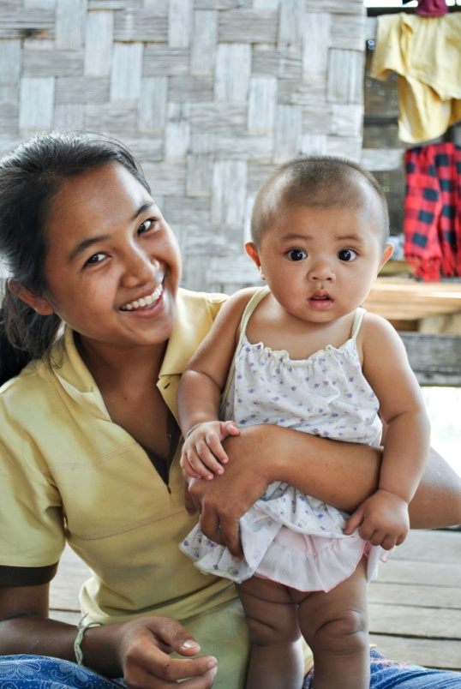
OUR VISION: HEALTHY CHILDREN FOR A HEALTHY WORLD

It is unacceptable that nearly 7 million children under the age of five are dying from preventable diseases each year. World Vision is committed to improving the health and nutrition of women and children in the areas where we work, contributing to the global reduction of under-five and maternal mortality.

OUR FOCUS: CHILD WELL-BEING

World Vision is focused on three essential outcomes to achieve the above goal:

Mothers and children are well-nourished.

Mothers and children are protected from infection and disease.

Mothers and children access essential health services.

THE 7-11 STRATEGY

World Vision’s Global Health strategy is founded on evidence-based and cost-effective preventive practices. We are working to scale up, in all our programmes, the following minimum set of contextualised interventions – 7 for pregnant women and 11 for children 0-24 months:

Targets | Pregnant Women: -9 months | Children: 0-24 months
Core interventions | 1. Adequate diet  2. Iron/folate supplements and Deworming  3. Infectious Diseases prevention: Tetanus toxoid (TT) immunisation, PMTCT of HIV and STI, TB Screening  4. Malaria prevention, treatment access and intermittent preventive treatment  5. Healthy timing and spacing of pregnancy  6. Birth preparedness (includes preventing postpartum haemorrhage using misoprostol)  7. Facilitate access to quality maternal health services:  Antenatal and postnatal care, skilled birth  attendance | 1. Appropriate breastfeeding  2. Essential newborn care (includes Chlorhexidine for umbilical cord care)  3. Adequate diet (includes appropriate complementary feeding and Vit A supplementation  4. Adequate iron  5. Full Immunization for Age  6. Hand washing with soap  7. Oral re-hydration therapy/Zinc  8. Prevention and care seeking treatment for acute respiratory infection and malaria  9. Prevention, care seeking and treatment for acute malnutrition  10. Prevention and care seeking for paediatric HIV (includes ARV and co-trimoxazole prophylaxis)  11. De-worming (+12 months)

HOUSEHOLD, COMMUNITY AND NATIONAL-LEVEL APPROACHES

Focus primary health and nutrition education and behaviour change at the household level, empowering caregivers to keep themselves and their children healthy.

Build the capacity of community groups to address and monitor local causes of illness, death and malnutrition; advocate for quality health service delivery and monitor home-based care services.

Emphasise partnerships with national government and other stakeholders to ensure delivery of quality health and nutrition services at the community level.

© 2014 World Vision International

