Mother-led MUAC – Community Mobilisation Approach

Project : xxx

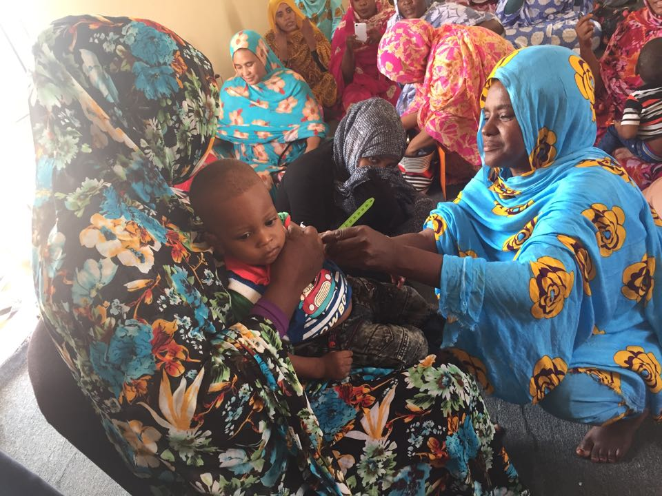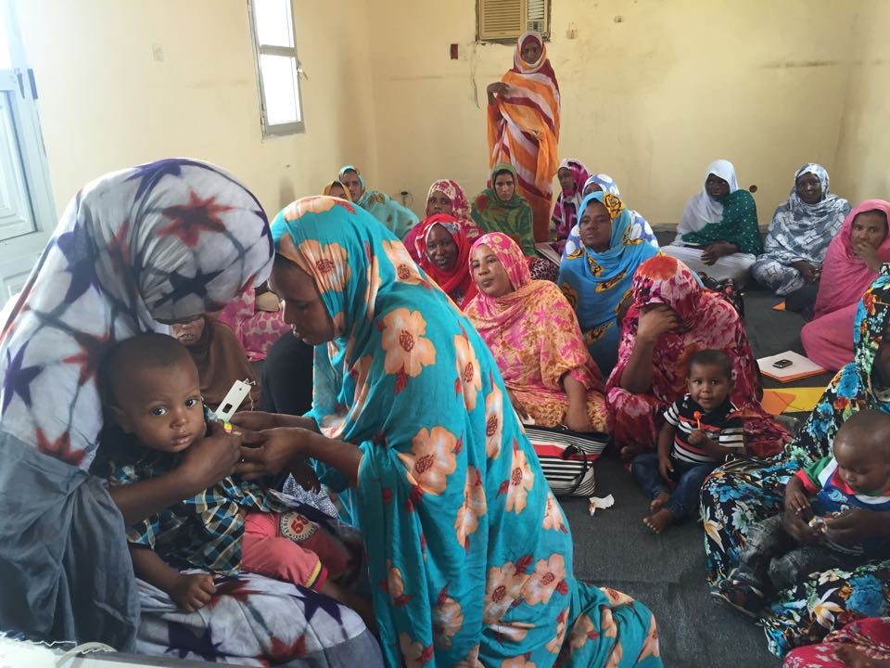
Practical session during Community Health Workers training: Mothers measure MUAC of their child with MUAC tape

Mother-led MUAC is an approach to identifying and diagnosing malnutrition by mothers. Mothers use MUAC tapes to measure the Mid-Upper Arm Circumference (MUAC) of their children and are taught how to detect oedema.

- Mothers receive mass introductory training in groups in the village at meetings of individual or peer-educator mothers at home.
- The introductory training sessions are given by Community Health Workers and are supported by community project facilitators in collaboration with health staff.
- Community Health Workers carry out tests at home several weeks after the initial training. If 25% of the results prove unsatisfactory they will organise refresher training.

Advantages of this approach

- The Mid-Upper Arm Circumference is a better predictor of mortality for children aged 6 to 59 months than the weight for height ratio, particularly if it is used regularly.
- It has been shown that regular screening in the community results in earlier detection thereby reducing the risk of mortality and morbidity.
- Mothers can classify their children according to the colour of the tape in the same way as Community Health Workers (according to a pilot study undertaken in Niger).
- The precision of the method is not affected by the choice of arm (left or right), nor by the way the midpoint is chosen (by eye or by measurement).
- Mothers / caregivers who have been trained have shown they are equally as capable of measuring the MUAC and identifying oedema as Community Health Workers.
- The earlier severe acute malnutrition is detected by mothers, the less hospitalisation is necessary for children who have been screened (according to a pilot study undertaken in Niger).
- The Community Health Workers continue to play an important role in the community. It seems more appropriate to train them to instruct mothers than to screen children themselves.
- Compared to a strategy relying solely on Community Health Workers, screening costs are considerably reduced by working with mothers.

Monitoring the efficacy of the approach

Follow up and monitoring of the efficacy of screening by mothers will be undertaken in the community and also at health centres:
- At community level :
Community Health Workers will carry out random tests in homes several weeks after the initial training session for mothers. Refresher training will be organised if 25% of results prove unsatisfactory. Knowledge of malnutrition and frequency of screening will be compared before and after the project intervention.

- At the OTP :
Staff will monitor and document whether the mother has been introduced to the Mother-led MUAC approach, whether she has screened her child herself, and the correlation between the colour of the MUAC and presence of oedema reported by the mother on arrival at the centre and the measurement taken by a health professional. If the measurement does not tally, health staff will automatically provide a refresher of the original screening training for the mother on taking the MUAC and checking for oedema. The median MUAC on admission to the programme, the rate of oedema, and the number of cases treated by month will be compared before and after the project intervention.

Alé et al. Archives of Public Health (2016) 74:38, DOI 10.1186/s13690-016-0149-5
Ibid.

