# C:\Users\JAMES\Desktop\may CFS Activities\WP_20140530_10_13_42_Panorama.jpg**REBUILDING THE lives OF SOUTH SUDANESE REFUGEE CHILDREN FROM ASHES**

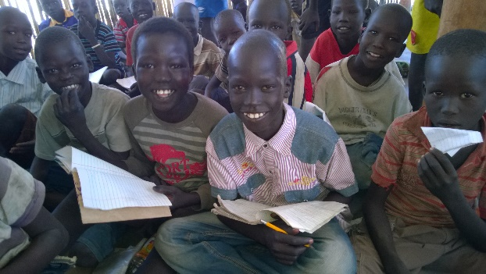

**Impact stories.**

**.Child friendly spaces**

**.Early childhood care and development centers**

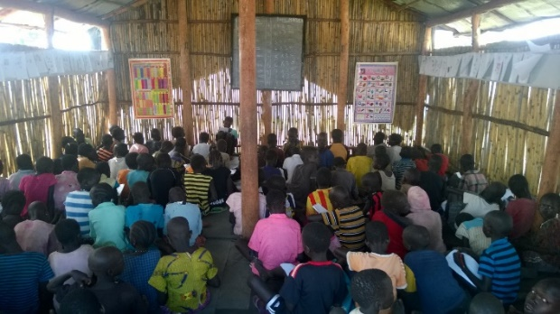**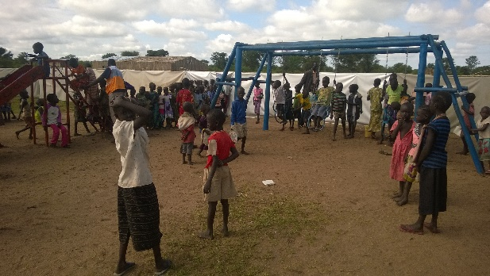**Deep within little hearts lies super heroes, among them are the South Sudanese refugee children who bear the brunt of the conflict in their country. They make 66% of the current 81425 refugee population (44066 female and 37359 male) settled in Adjumani district since the influx began. Caught up in a political conflict characterized with ethnic distrust, these children have a lot of unanswered questions of why this whole situation and wish they were the leaders of the day to change it. A reflection on life in their country is filled with sad events and memories of losing their homes, friends, loved ones and schools where they always interacted with childhood peers. Presently, some of them are separated from their families, unaccompanied and in a new environment. They are coping up with the whole situation and accepting their new home as World Vision Uganda together with other partners rebuild their hope from ashes in achieving the child wellbeing aspirations. This is through implementation of the child friendly spaces, early childhood care and development centers and the infant and young child feeding projects.

**Children in a class at an ECD center**

**Children in a class at an ECD center**

Abraham is a refugee children’s’ club leader at the child friendly space who expresses himself through a poem he wrote and displayed in one of the shelters at the spaces. Just like other children, his poem has unanswered questions though with a ray of hope that the time for children to be leaders will come.

**Children enjoying play in the CFS**

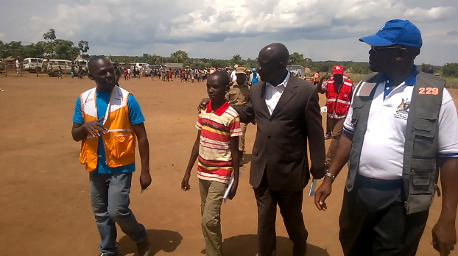

“I break into tears! Oh God! Oh God!

Did you identify me to be a refugee?

I was born in a refugee camp and grew up in a refugee camp.

Do you want me to get old in a refugee camp again?

Not only me but the whole continent of Africa is a victim.

Did you plan Africans to be refugees? For how long?

Why don’t you choose any child among us to be a leader?

**James our staff, Abraham, Hon. Minister of state for disaster with the Refuge Desk Officer during a visit to the ECD center**

For at least one day and see whether he can be corrupt.

You leaders! You are the root cause of our suffering.

There you eat and corrupt to bring wars.

Don’t forget our time will come, we are supposed to unite.

**CHILD FRIENDLY SPACES (CFSs)**

The 4 child friendly spaces by World Vision Uganda in Nyumanzi and Ayilo refugee settlements are attracting ages of 3 and 17 years in assorted sessions facilitated by trained caregivers. Children receive psychosocial support through structured play and learning for both boys and girls. 2156 boys and 1528 girls have been supported to deal with the distress and this has facilitated them to enroll in the ECD centers and primary schools both within the settlements and host communities. There were a number of cases of children fighting amongst each other at the child friendly spaces and schools but Peace building committees have been initiated by parents to reconcile and build co-existence mechanisms.

**“In the first months of our settlement here, children were so distressed and unfriendly to each other. They would fight every time and this would even affect their parents. For example one day, a boy kicked a girl and injured her. The mother of the girl went to the boy’s home and asked the boy’s mother why she has not disciplined her son after he injured her daughter. The girl’s mother slapped the boy and in the end the two mothers fought and the community was in a mess. The peace committee at the child friendly space reconciled the two since the children had to attend the child friendly space and school. It has helped in avoiding such scenarios from happening in our community again. Boys and girls have also formed peace clubs through sports which compete amongst each other and also preach reconciliation at these spaces. This has seen fighting among children reduce”,** Remarks Mabior, a community member and parent in Nyumanzi settlement.

**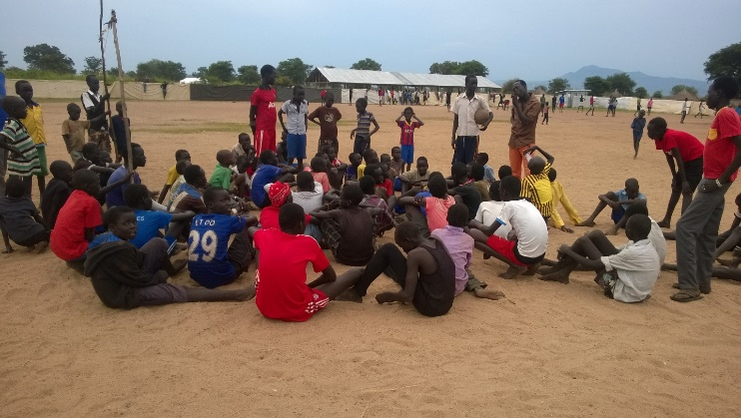**

**Children leaders talking to fellow children on reconciliation after a football game at the child friendly space**

**EARLY CHILDHOOD CARE AND DEVELPOMENT CENTRES (ECDs)**

Early childhood care and development centers (ECDs) are integrated in the child friendly spaces. These are providing children with the cognitive development and also feed into the community initiated primary schools. They are monitored by the districted education office and are implemented using the ECD learning frame work of Uganda. During the end of last term, 3486 children were assessed and t report shared by parents during parents’ meetings facilitated by the center management committees. To both parents and children, this was historical as it was the first school assessment since they came to Uganda.

**“Am so excited looking at the work of my son from this ECD center. This is the very reason I came to Uganda so that my children can attain education since I never went to school and we are in a competitive generation. It’s something I never expected this early but World Vision through our teachers has done it for us. Before coming for this meeting, I first assessed my son in reading the alphabet and the body parts with the help of his elder sister who is in grade two at the community primary school. I was amazed at the answers and it has given me joy because they will be different from me their father who learnt the alphabet while I an adult to help me write my name. I credit the ECDs for what they are doing for our children and when we go back to South Sudan one day, we will always remember world Vision in our hearts”.** Remarks Jacob Majere, a community leader and parent during the ECD parents review meeting for their children assessment reports.

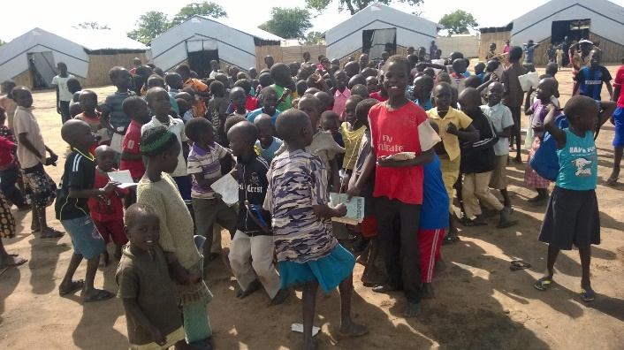

**Children playing at break time after ECD sessions**

**At the child friendly space**